1. **There are 4 environments**

* Dev
* QA
* Prod
* DR(disaster Recovery)

1. In SAP BODs code always saved in .ATL format
2. Command to Logout: **exit**
3. **Wasadmin** used to perform admin activities
4. Based on environment given, load the server in puTTY configuration

* For QA : BODS-QA
* For Dev : BODS-DEV

1. CMD to get IP address : ping sapbods.qa.ins.aws.aaa-acg.net
2. Credentials to login into QA & DEV BODS: ssm -user
3. CMD to get access as a sudo user: sudo su -wasadmin
4. Path to import and export on all environments:

Cd /opt/app/sapbusinessobjects/dataservices/Scripts

1. Cmd to list all files: **ll**

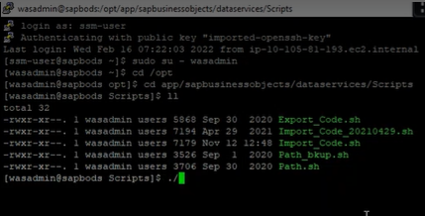

1. CMD to export file: **./Export­_code.sh QE2E BOUND**

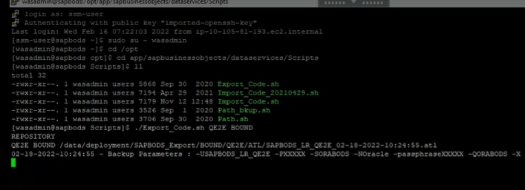

1. CMD to come out of current path: **cd /**

**cd log --🡪 to see all log files**

**ll**

**cd Export/**

1. CMD to know present working: **PWD**



Note: When exported(backup) is successful then based on current(today) date create .log

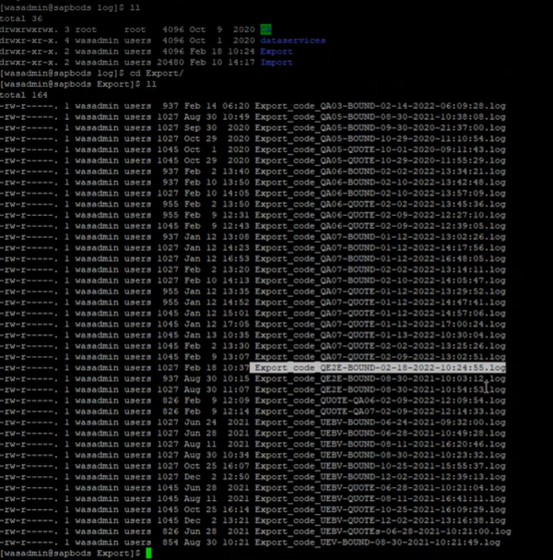

1. CMD to view files: **cat file_name.log**

**Note:** always check repository name after backup

1. Steps to double check backup file is backup or not:

* ~~Cd / --------🡪Root~~
* ~~Pwd~~
* ~~Cd data~~
* ~~ll~~

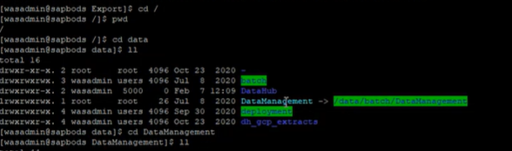

* ~~cd DataManagment (dircetory name)~~
* ~~ll~~
* 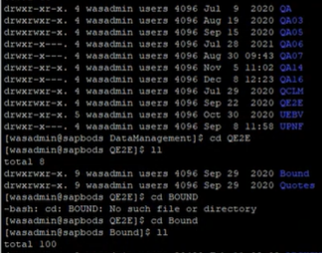
* ~~Cd QE2E~~
* ~~ll~~
* ~~cd Bound~~
* ~~ll~~
* ~~cd /~~
* cd /data/deployment – check from here
* ll
* cd SAPBODS_Exports
* ll
* cd BOUND
* ll
* cd QE2E
* ll
* cd ATL ----🡪 Files always be in ATL format so go inside ATL directory
* ll

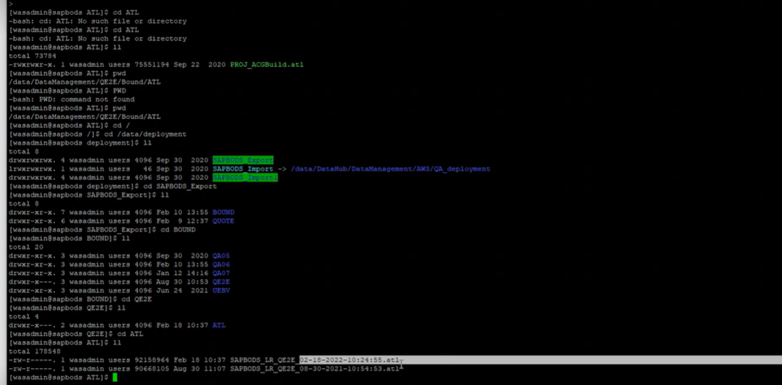

* cd /

1. Import Steps

* Cd /opt/app/sapbusinessobjects/dataservices/Scripts
* ll
* ./Import_code.sh QE2E BOUND
* Uname -a

(‘uname‘ displays the information about the system. And **-a option**: It prints all the system information in the following order: Kernel name, network node hostname, kernel release date, kernel version, machine hardware name, hardware platform, operating system)

* 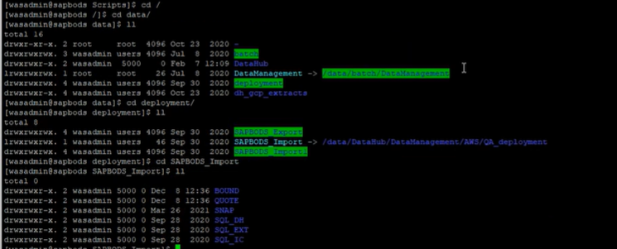
* Cd /
* Cd /data
* ll
* cd deployment/
* ll
* cd SAPBODS_Import
* ll
* **Note: cd /data/ deployment/ SAPBODS_Import/** BOUND/QE2E/ ATL

**-** developerand refresh will keep file inside this path

* cd BOUND/
* ll
* cd QE2E
* ll
* cd ATL
* ll

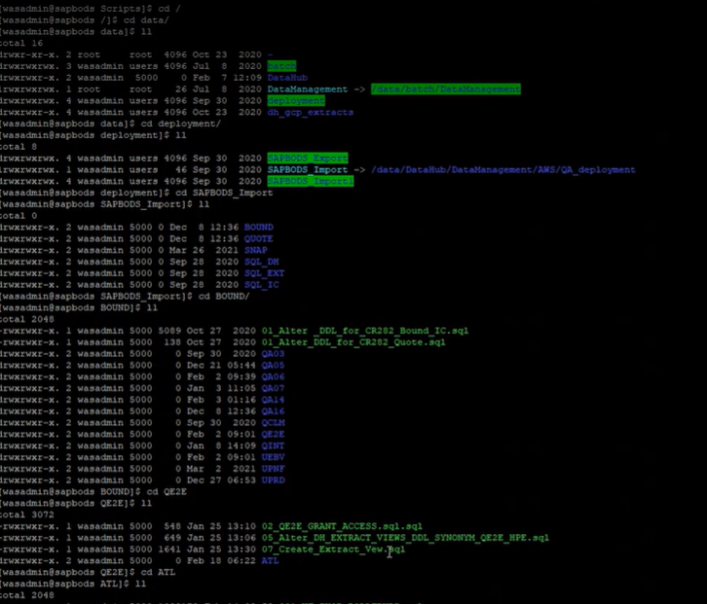

* Cd /opt/app/sapbusinessobjects/dataservices/Scripts
* **ll**
* ./Import_code.sh QE2E BOUND
* Note: Developer will keep import files in AWS/QA_Deployment /../Bound(QUOTE)/

**To check all import files**

* **cd log --🡪 to see all log files**
* **ll**
* **cd Import/**